**Write-Up for Step 1 (Data Preparation)**

**Step 1: Data Preparation**

The first step in creating the Sales Dashboard is preparing the dataset for analysis. The dataset was loaded into Excel from the file **“E-Commerce Dashboard dataset.xlsx”** and reviewed for data consistency.

* **Data Consistency Check:** The dataset was examined to ensure correct data formats. The **Order Date** and **Ship Date** columns were confirmed to be in date format, while numerical fields like **Sales, Profit, and Discount** were verified for accuracy.
* **Missing Value Handling:** A review of the dataset revealed no major missing values. If missing values were present, appropriate replacements (such as using average values) would have been considered.
* **Key Fields Verification:** The dataset contained a **Months** column for time-based analysis and properly categorized **Regions and Product Categories** for segmentation.

Attaching screenshots for each step

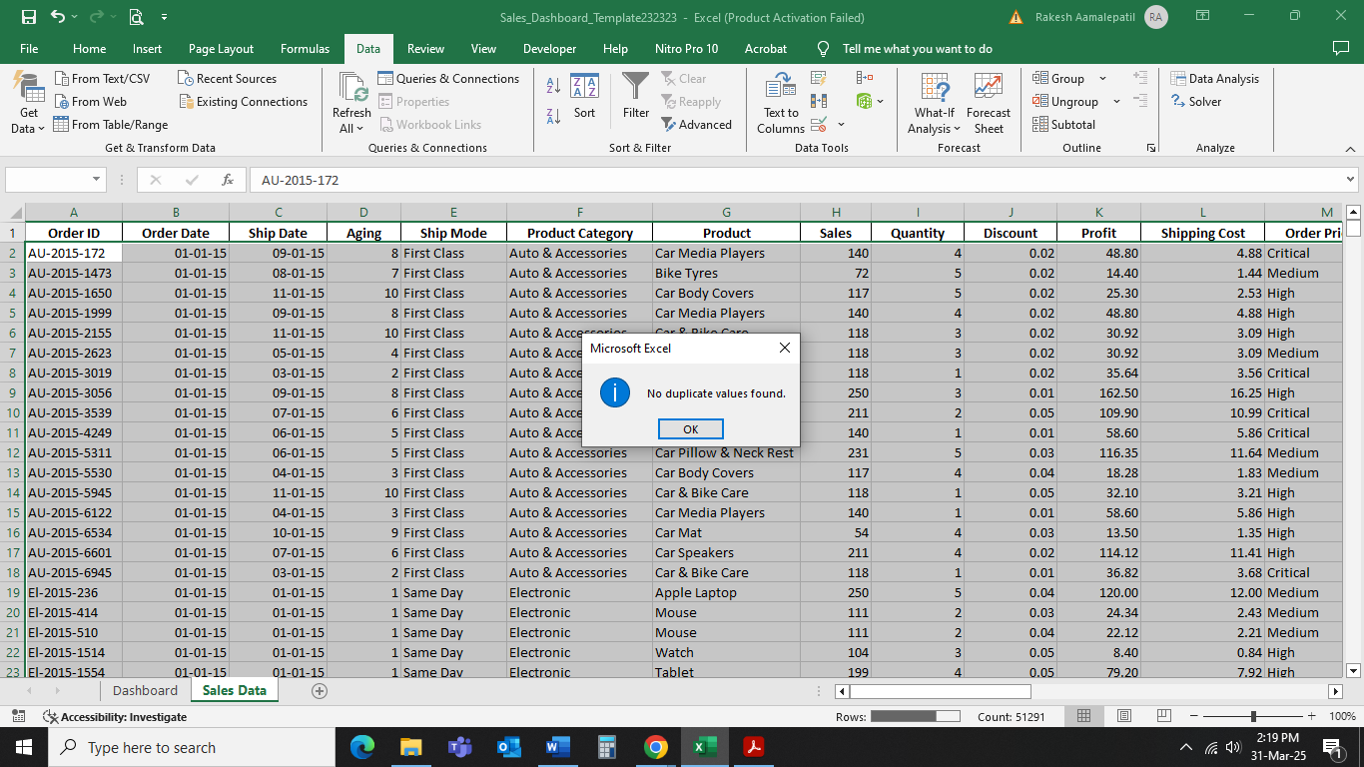

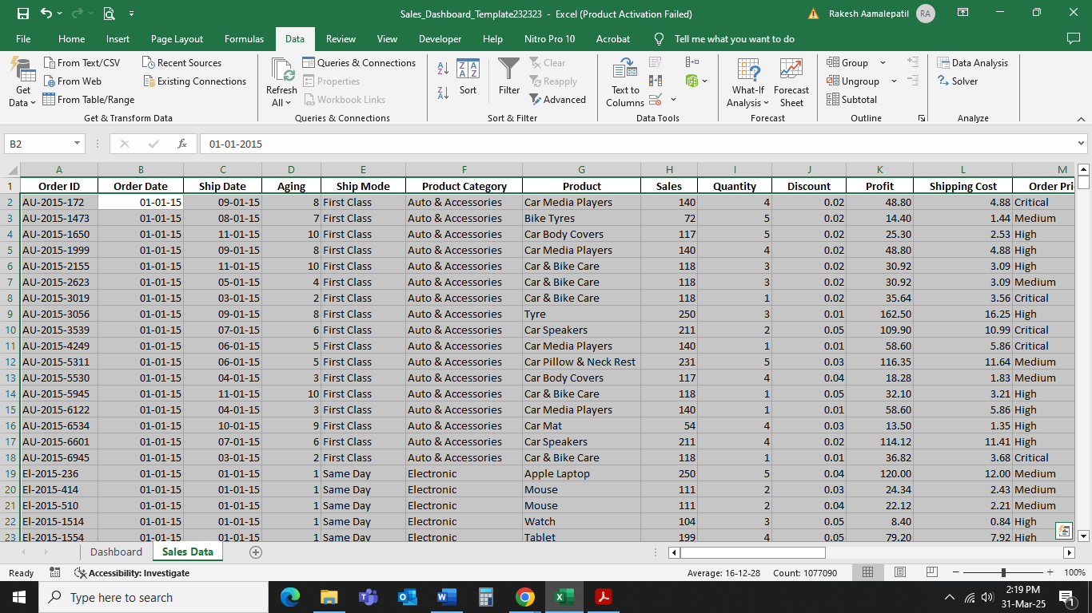

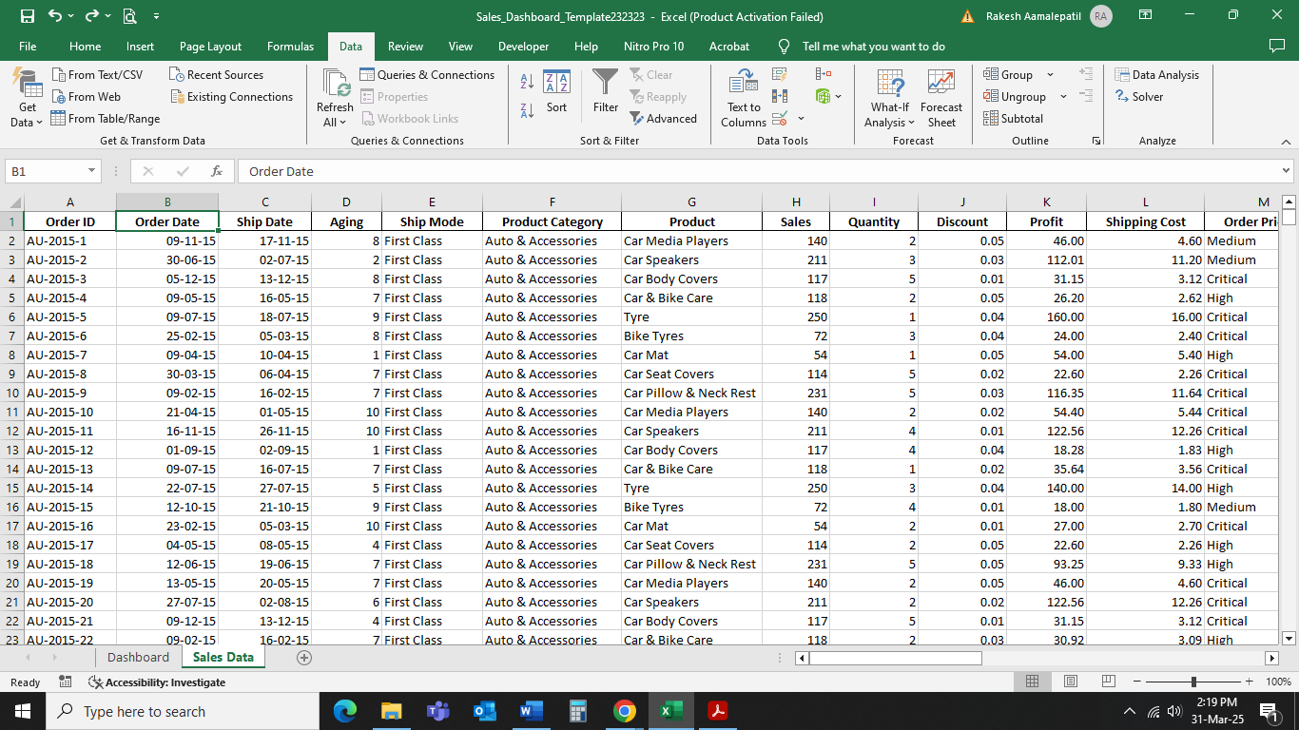

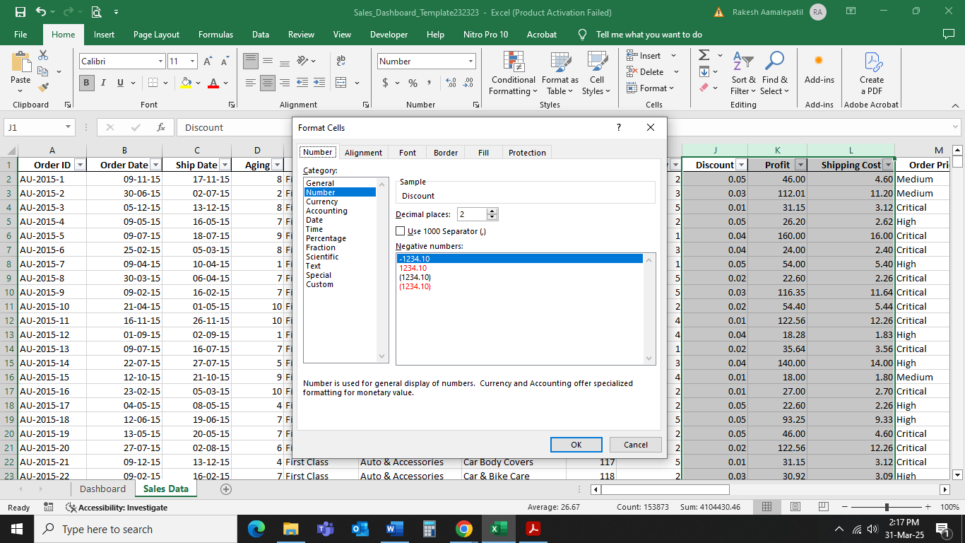

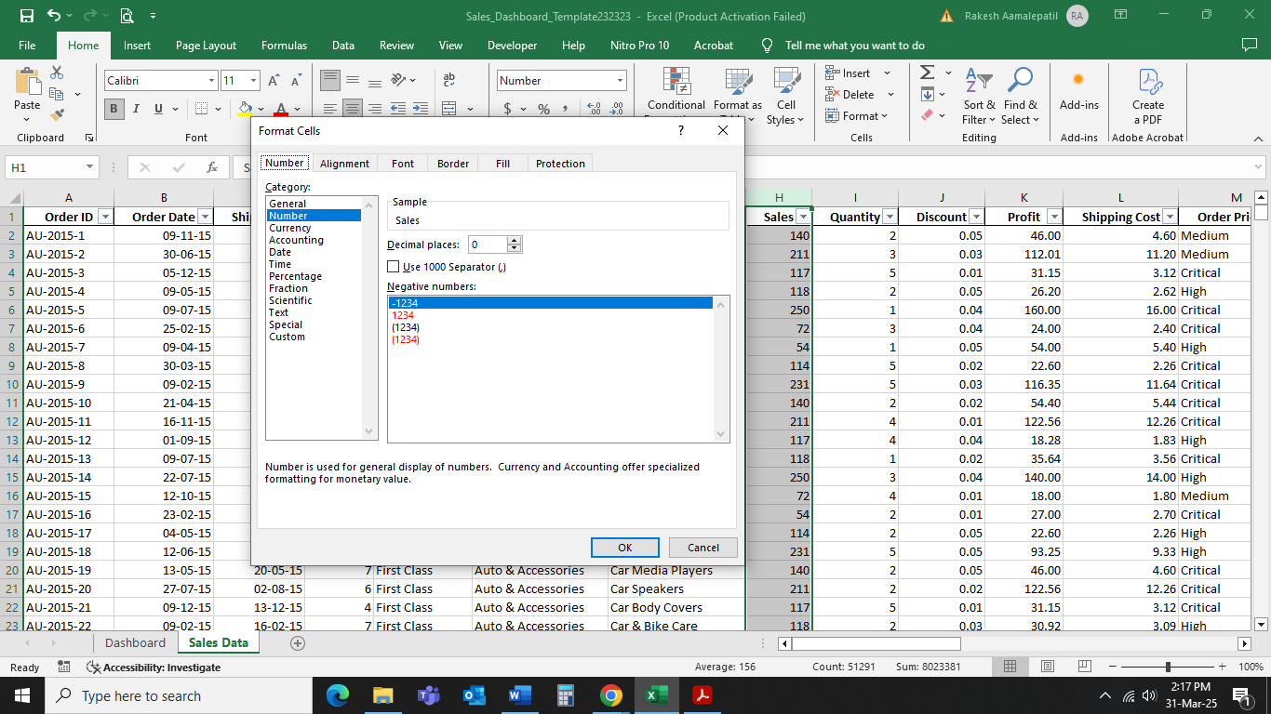

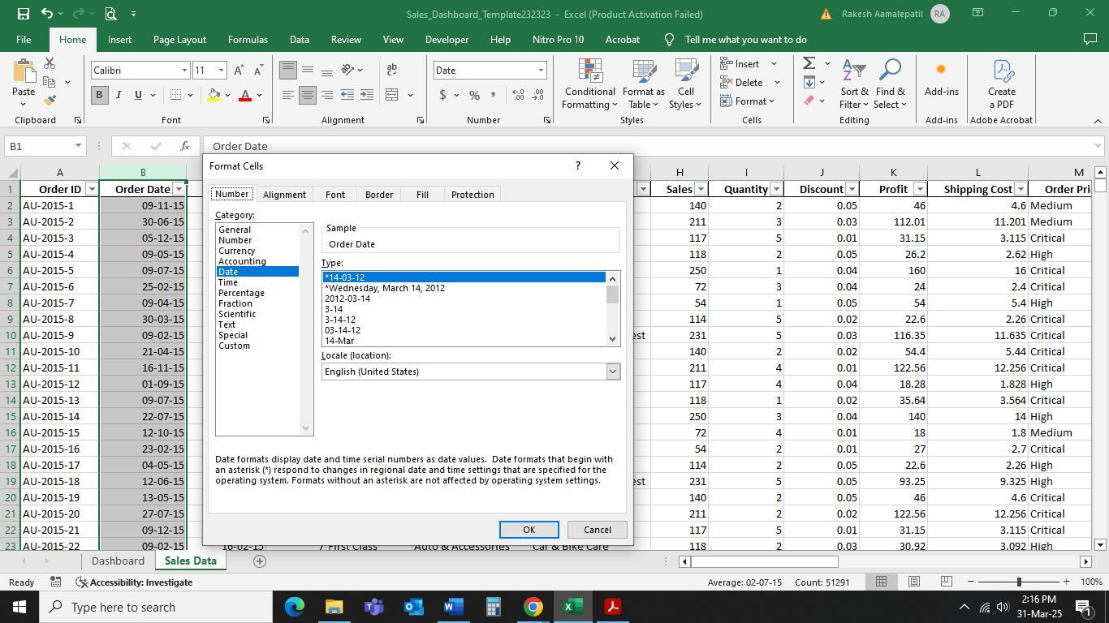

**Step 2: Creating a Histogram for Shipping Days (Aging)**

To analyze the distribution of shipping durations, a histogram was created using the **Aging** column in the dataset. The following steps were performed:

* **Data Preparation:** A **Bins column** was created to categorize shipping durations into ranges (e.g., 2, 5, 7, >10 days). This helped in grouping orders based on delivery time.
* **Data Cleaning:** The **Aging column** was checked for non-numeric values. Any blank or text values were corrected to ensure proper numerical analysis.
* **Histogram Generation:** The **Data Analysis ToolPak** was used to create a histogram by selecting:
  + **Input Range:** Aging column
  + **Bin Range:** The predefined Bins column
  + **Chart Output:** Enabled to visualize the results
* **Chart Formatting:** The histogram was formatted for better readability, with axis labels for **Shipping Days (X-axis)** and **Order Count (Y-axis)**.

This histogram helps in identifying trends in delivery times and potential delays in shipments.

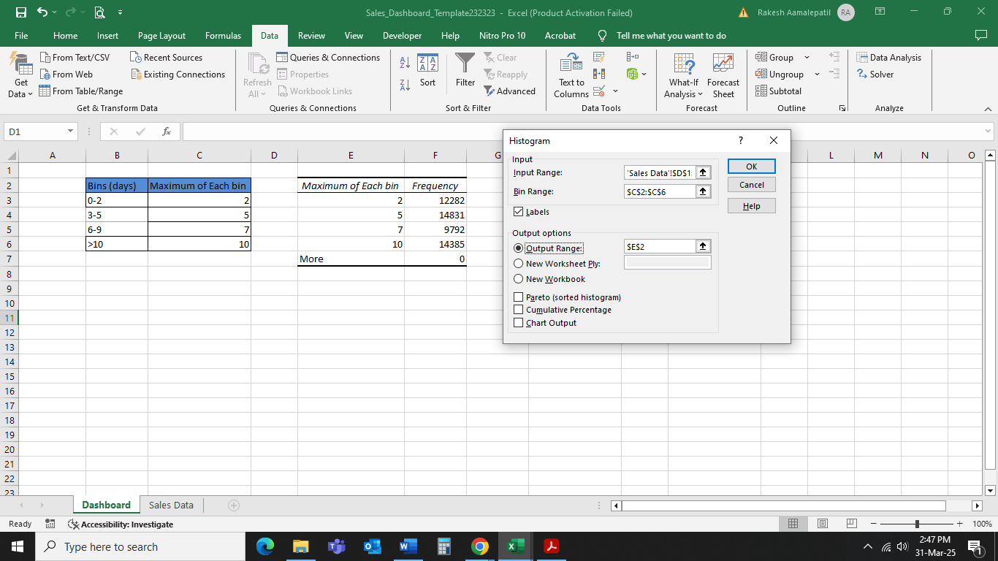

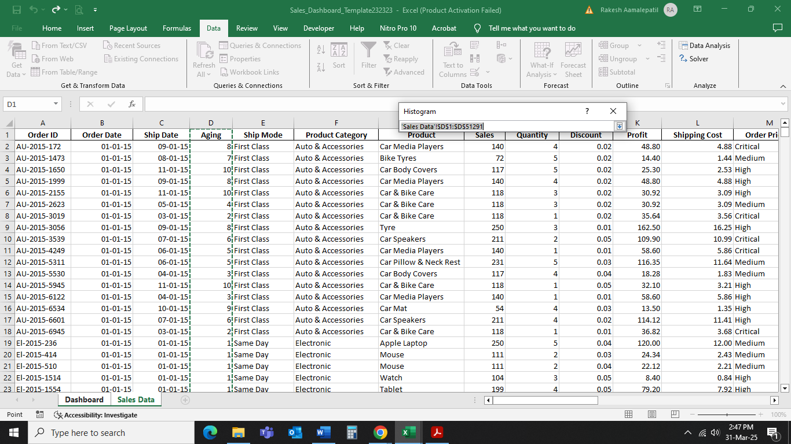

**Step 3: Creating Summary Tables for Sales Analysis**

To analyze sales trends, two summary tables were created using **PivotTables**:

* **Month-wise Sales and Profit Table:** This table summarizes **total Sales and Profit per month**, allowing us to track seasonal sales performance.
* **Region-wise Sales Table:** This table displays **total Sales for each region**, helping to identify top-performing and underperforming areas.

The **PivotTable feature** in Excel was used to efficiently summarize the data. Sales and profit values were formatted as **Currency** to improve readability. These tables will be linked to visual charts in later steps.

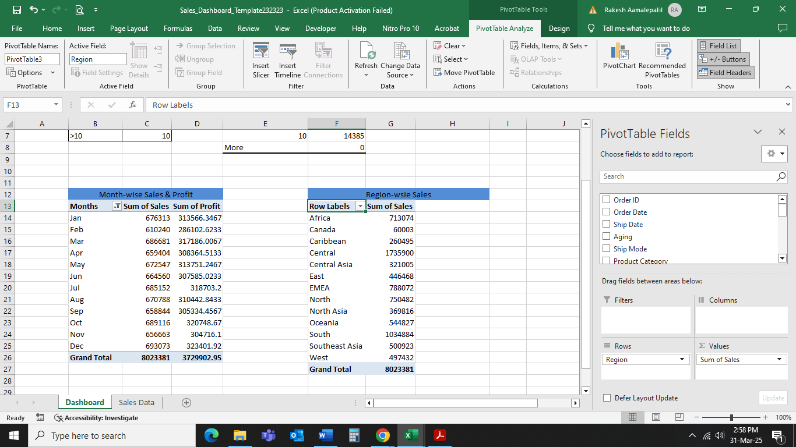

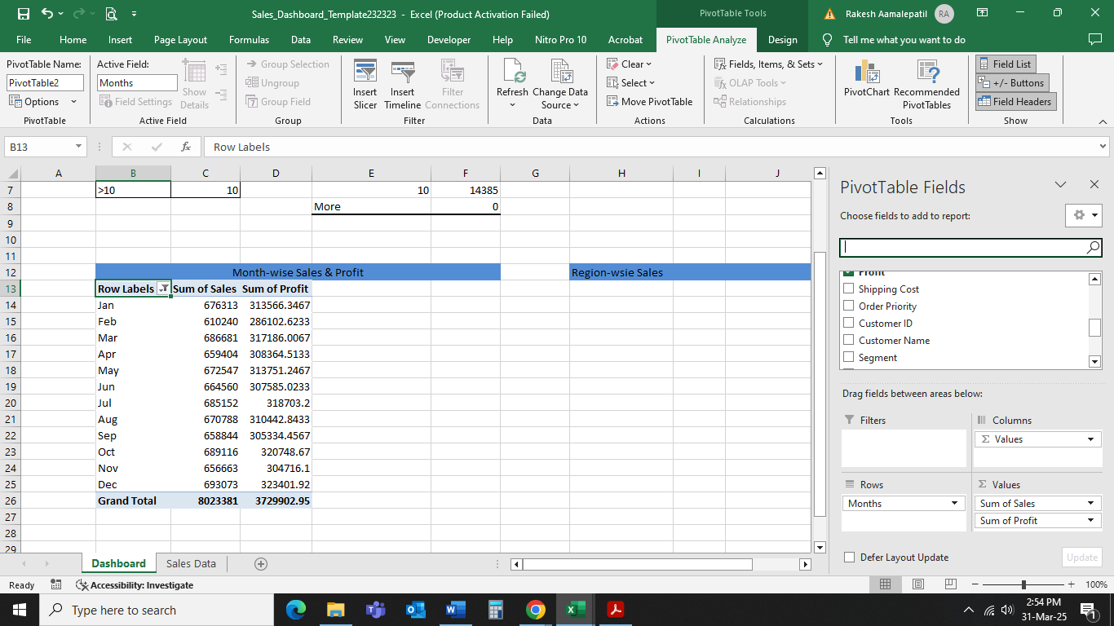

**Step 4: Creating User Control (Combo Box) for Product Category**

To enhance interactivity in the dashboard, a **Combo Box** was created to allow users to filter sales data by **Product Category**. The following steps were performed:

1. **Enabled Developer Tab** to access Form Controls.
2. **Created a list of unique Product Categories** to serve as input for the Combo Box.
3. **Inserted a Combo Box and linked it to the ProductCategoryList** so users can select different categories.
4. **Connected the Combo Box to PivotTables using a Slicer**, ensuring all tables and charts update dynamically.

This feature improves usability, allowing easy filtering and analysis of sales performance for different product categories.

**Step 5: Creating Column Charts for Monthly and Regional Sales**

To better visualize the sales trends, **Column Charts** were created for:

1. **Monthly Sales & Profit:** This chart shows total sales and profit for each month, helping to analyze seasonal trends.
2. **Regional Sales:** This chart displays total sales for each region, identifying the best and least-performing locations.

The charts were created using the **Clustered Column Chart** option in Excel. Formatting was applied, including **titles, data labels, and currency formatting**, for better readability. These charts were then placed in the **Dashboard sheet** to be part of the final dashboard.

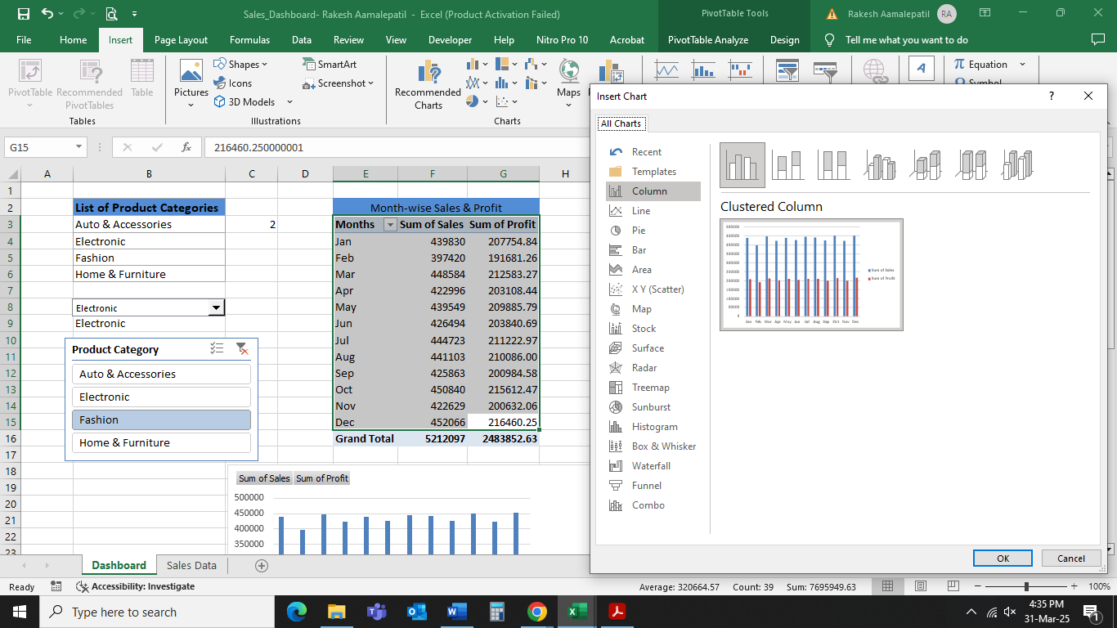

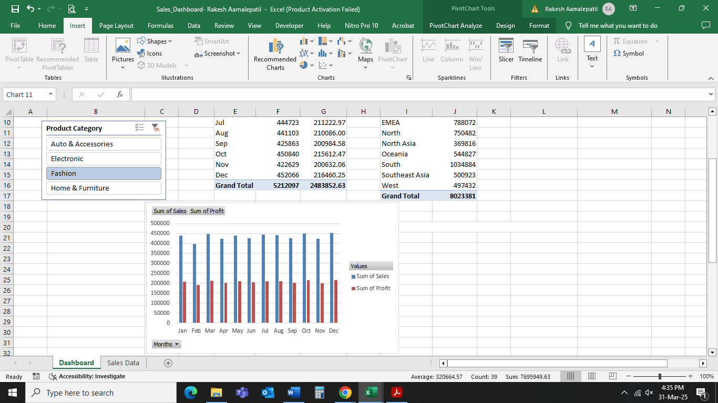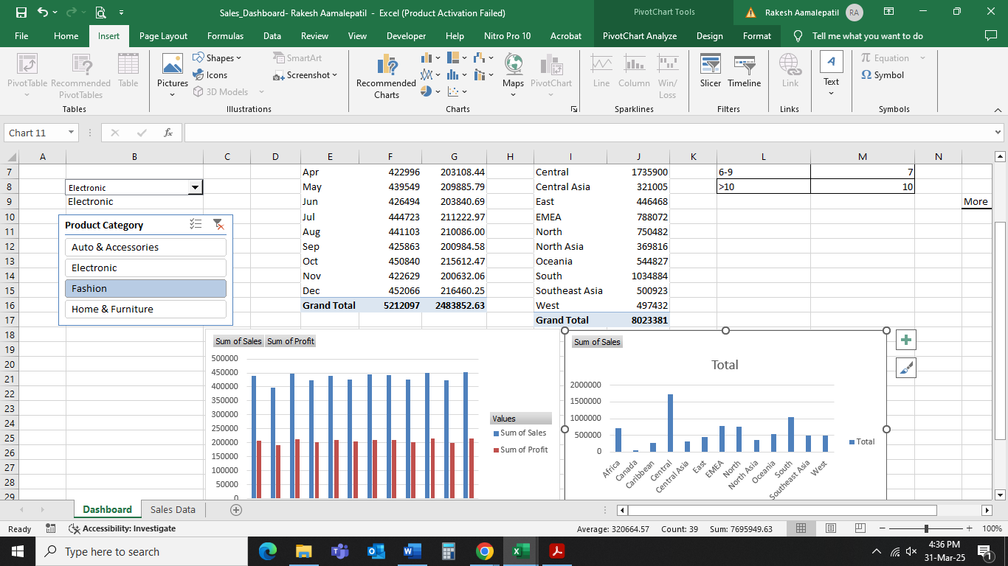

**Step 6: Linking Charts with the Combo Box for Dynamic Filtering**

To make the dashboard interactive, the **Combo Box (Drop-down List)** was linked to the PivotTables using a **Slicer**. The following steps were performed:

**Connected the Product Category Slicer** to all PivotTables, ensuring the tables and charts update dynamically.

With this setup, the dashboard provides **real-time analysis** of sales trends by Product Category, improving usability and insights.

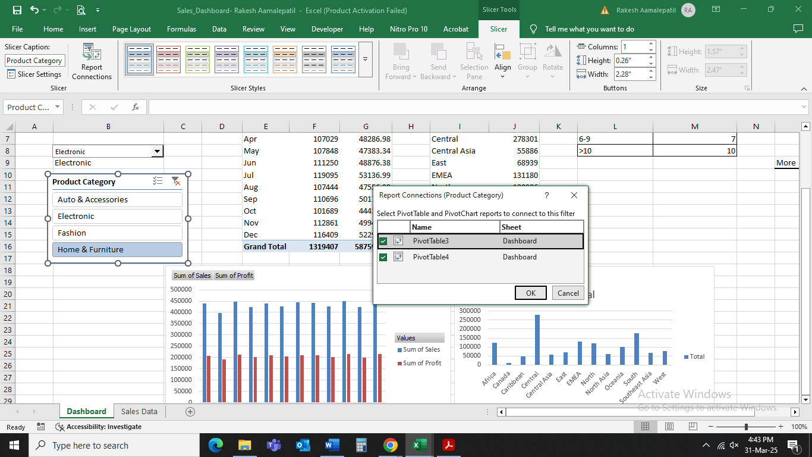

**Step 7: Finalizing the Dashboard Layout and Design**

The final step focused on **organizing and formatting the dashboard** to ensure a clear and professional layout. The following enhancements were made:

1. **Arranged dashboard elements properly** to provide a structured and intuitive flow.
2. **Formatted charts and tables** with colors, borders, and conditional formatting for better readability.
3. **Tested all interactive features**, including the Combo Box and Slicer, to ensure smooth functionality.

The final dashboard provides a **dynamic and visually appealing sales analysis tool**, allowing users to gain insights at a glance.